- The server will go right here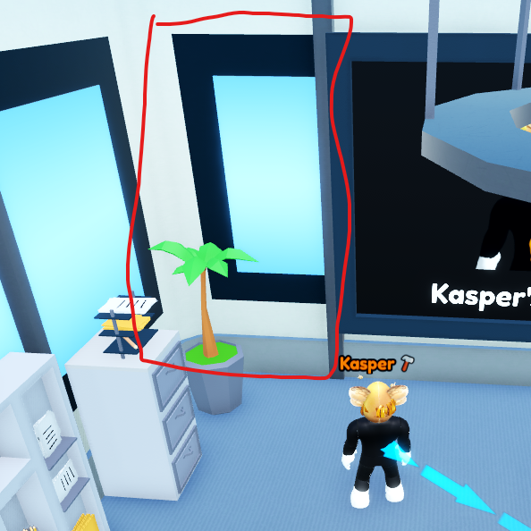
- I think this kind of colour scheme would be good
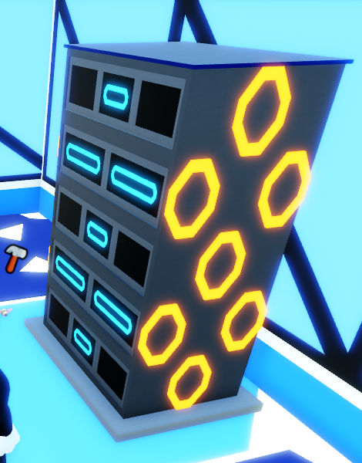
- The server should look like a server
It would be just one column of servers though


- There will be bars as part of the server
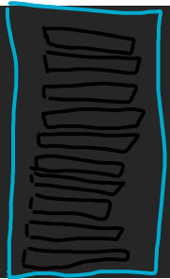
The bars should be neon and there should be exactly 10 bars. (The bars will turn bright when you have unlocked that storage)

